Havo / VWO B1E Onderwerp: Vermenigvuldigen en delen en haakjes

1  5 × –4 - 8:8 = | 2  –16 : –4 x 3 - 5= | 3  –8 × –4 = | 4  (–7 × –7) – 8 x 7= | 5  6+3 x (12 –3 )= | 6  6 x 3 - (12+39) =
7  6 + (4 × 7 ) : 2= | 8  (–16 : –8) + 8 :2 + ( 6 x 3) = | 9  (–48 : 6) x 2 : 2 = | 10  4 x 3 + 2 : 2 x 8 = | 11  (6 -1) x 10 : 2 + 5= | 12  (7 + 3 ) x 4 : 2 -5 =
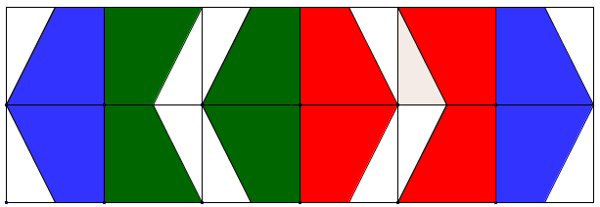

7 | 17 | -21 | 32 | 30 | –33
24 | -7 | 20 | 33 | –8 | 15

